A000-Indo-Sulawesi-Toraja-Grave guardian-early 20th century

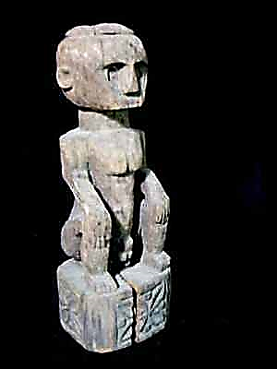 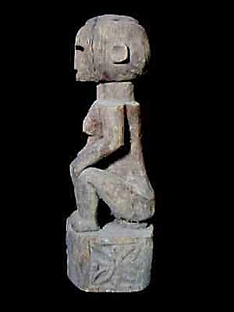 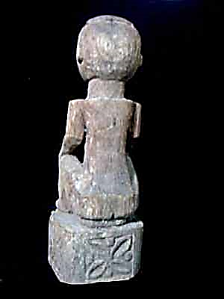 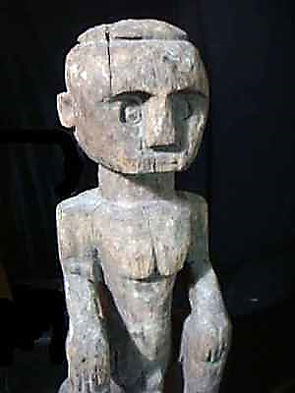

**Figs. 1-4.** Sulawesi-Toraja-Grave guardian-early 20th century

**Case no.: Oceania**

**Accession Number: A000**

**Formal Label:** Sulawesi-Toraja- Kabupaten Tana-Tau tau-Grave guardian-early 20th century

**Display Description:**

The Toraja, who live in Central and South Sulawesi, formerly known as the Celebes, speak an Austronesian, Malayo-Polynesian language and have an animist religion (Gordon 2005: 434). Their neighbors, the Bugis, are also an Austronesian-speaking people with an animist religion, Tolotang. Both groups had migrated to south Sulawesi around 2500 BCE from Taiwan after first emigrating from south China (Wen and Chen 2008). Thus, they were part of the Austronesian expansion that ultimately led to the Polynesian migrations into the Pacific islands. The Bugis call the Sa'dan-Toraja, To-ri-aja (To-ri-adja) that literally means “people from the interior” where there are many mountains up to 3,000 m high. So the Toraja are also considered mountain people. When the English arrived, they thought the Toraja’s name denoted a place “To” Raja”, but in Indonesian “raja” means "king" or "ruler,” so when the British referred to these people as people of raja they were in a sense called "people of high rank." To the Toraja, themselves, “raja” means “magnificent” or “handsome”. Thus, these three meanings of “Toraja” coalesce in referring to these people as “handsome people of high rank from the mountains”.

Although recent demographic figures are not available we do have the following statistics. There were about 325,000 Torajans (Nooy-Palm in Eliade 1987, Vol. 14, 565). In 1975 half of these practised Aluk To Dolo. Now this is estimated to be only 30 per cent. Of the remainder 60 per cent are Christian and 10 per cent Muslim (Dalton 1988, 845).

Tau tau are an effigy believed to have originated in the 19th century made of wood or bamboo particular to the Toraja ethnic group in South Sulawesi, Indonesia. The word "tau" means "man", and "tau tau" means "men" or "statue” (Blanche 2011).

They were once produced only for the wealthy, to reflect the status and wealth of the deceased (Sammut 2009). The tau tau are carved to show the gender of the deceased as well as imitating the likeness of the deceased. Nowadays, tau tau have photographic likeness to the people they represent. They are carved with wrinkles and carry items like Bibles (Adams 2006)

The types of wood used for the effigies and what they are clothed in also reflect the status and wealth of the deceased. Tau tau of the wealthy would generally be made of wood from the jackfruit tree (*Artocarpus heterophyllus*). They are usually permanent statues that can be found standing at the entrance of tombs, which are carved out of rock faces of Toraja. Their position, in reference to the other tau tau, in the rock face would indicate the status of the deceased. The cave builders usually require payment of several buffalos that only the sufficiently wealthy can afford (Blanche 2011).The less wealthy elites generally have their tau tau made from bamboo, which will be undressed at the end of the funeral, leaving only the bamboo on the ritual field. There are regional variations in the types of tau tau used, also.

**LC Classification:** DS632.T7

**Date or Time Horizon:** early 20th century

**Map:**

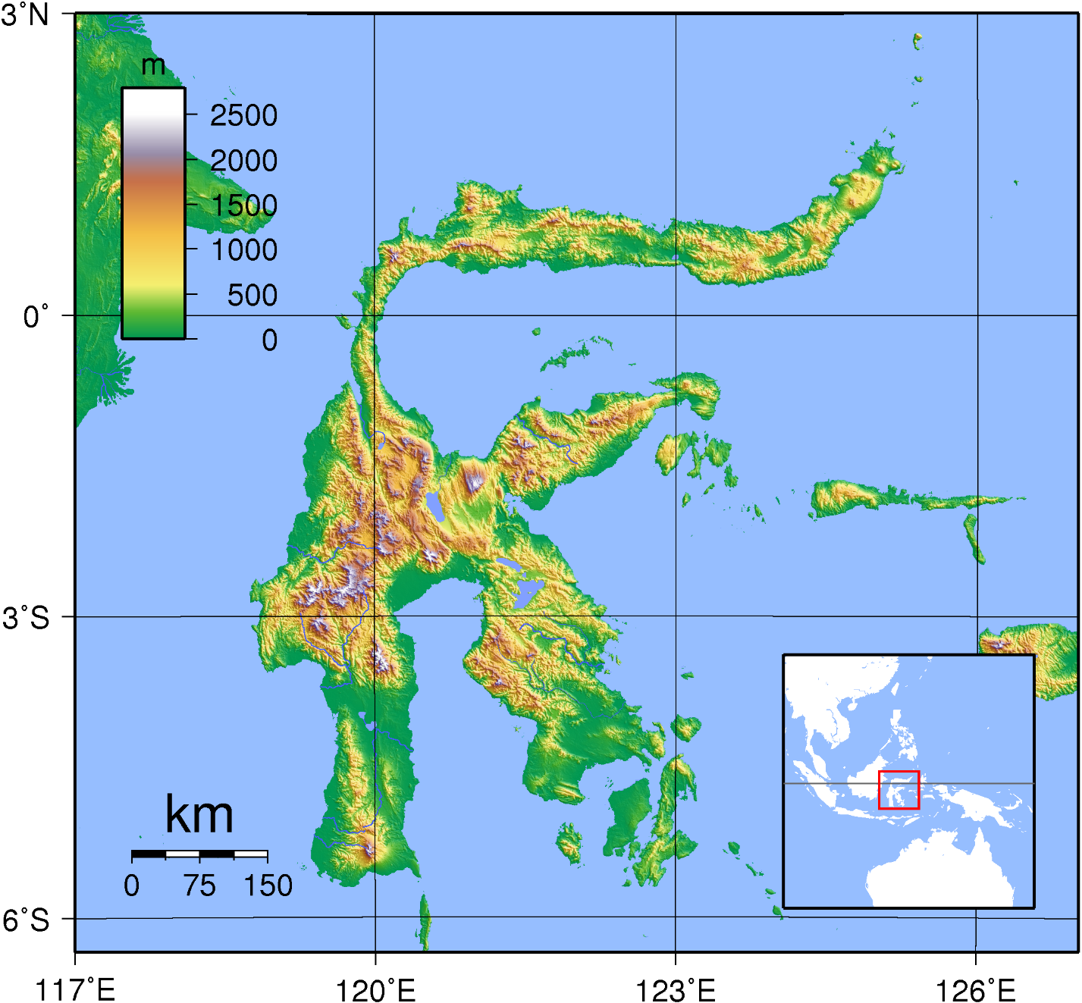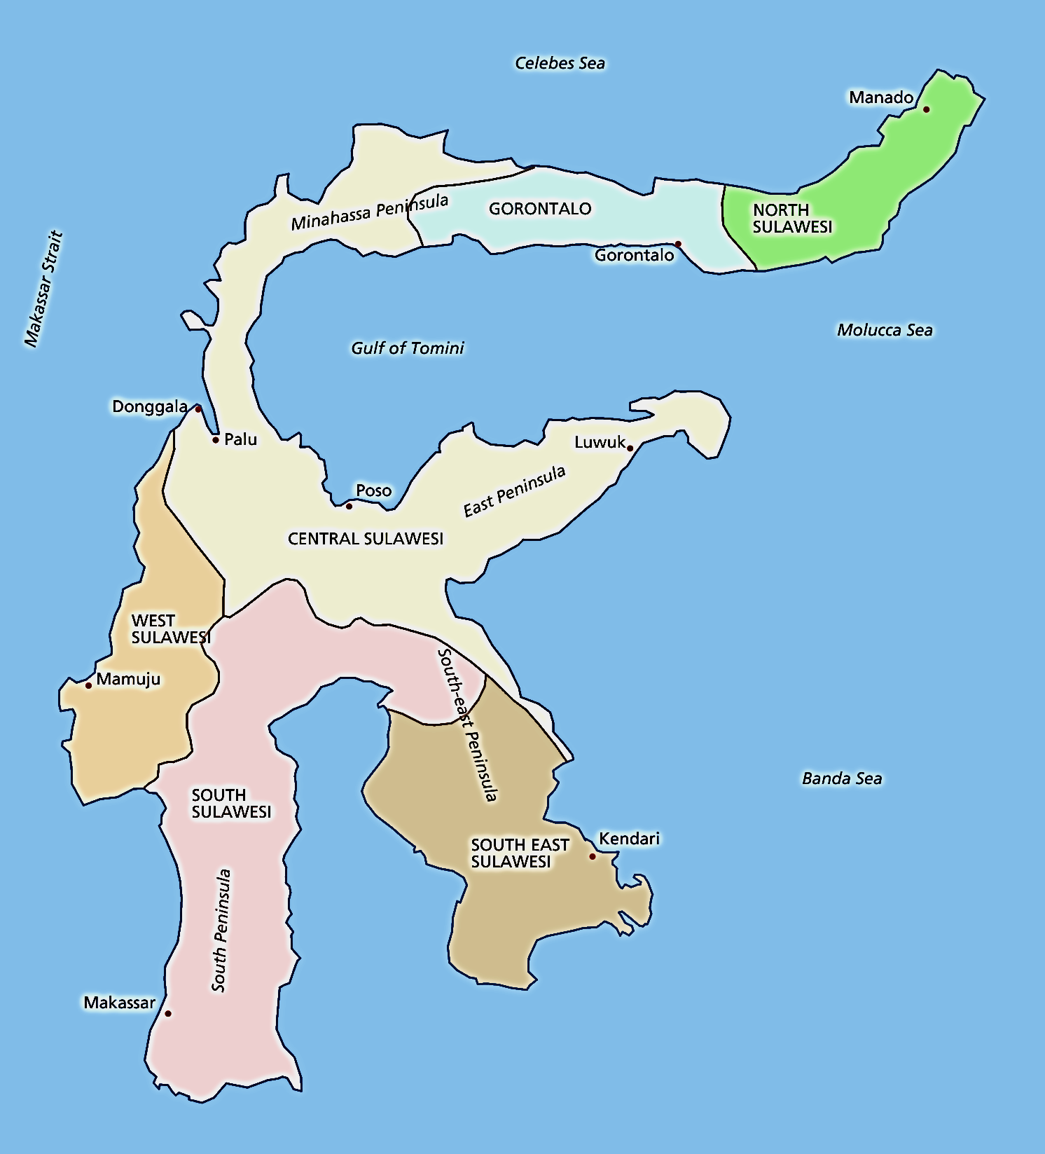

Map: Sulawesi

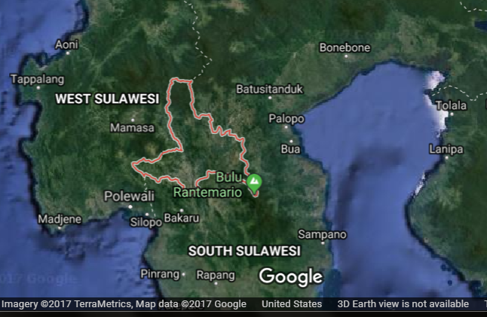**GPS coordinates: -3°22'54.00" S 120°01'43.00" E**

**Cultural Affiliation:** Toraja, Sulawesi, Indonesia

**Medium:** wood, patina of the figure is brownish-gray

**Dimensions:** H 30 in / 72 cm

**Weight:**

**Condition: original**

**Provenance**: grave figure of Toraja, Sulawesi, Indonesia

**Discussion:**

* In the early 1900s, with the arrival of the Dutch Christian missionaries in Toraja, the production of tau tau was somewhat dampened. At the 1985 synod of Toraja Church in Palopo people debated if Protestant Toraja could have tau tau at their funerals.[[3]](https://en.wikipedia.org/wiki/Tau_tau#cite_note-.5B.5BKathleen_M._Adams.5D.5D-3)
* Torajans believe that the dead can take their possessions with them to the after life, the effigies are usually equipped with small possessions. In 1980s, the wooden effigies became a target for grave robbers looted and possessions kept with them and sold the figures to museums. Tau tau can now be found in Jakarta, Europe and America, and were once even on display at the Smithsonian Institution in 1991 (Volkman 1990). In response to this plunder of the ancestors, the Torajans hid their tau tau in various undisclosed locations. They also installed metal fences surrounding their cave graves to protect the tau tau. It is somewhat ironic that the tau tau is meant to represent the deceased protecting the living, but they now have to be protected against the living (Adams 1993).
* **References**
* Adams, Kathleen M. 2006 *Art as Politics: Re-crafting Identities, Tourism and Power in Tana Toraja, Indonesia*. Honolulu: University of Hawaii Press.
* Adams, Kathleen M. 1993. "Theologians. Tourists. and Thieves: The Torajan Effigy of the Dead in Modernizing Indonesia," *Kyoto Journal*, 22: 38–46.
* Blanche, Patrick. 2011. ["The tau tau of the Toraja"](http://www.rawvision.com/rawvision/current/tautautorajas/tautautorajas.html). Raw Vision. Watford, Hertfordshire. https://rawvision.com/articles/tau-tau-toraja
* Gordon, Raymond G., Jr, ed. 2005. *Ethnologue: Languages of the World*. 15th ed. Dallas: SIL International.
* Li, H; Wen, B; Chen, SJ; et al. 2008. ["Paternal genetic affinity between Western Austronesians and Daic populations,"](http://www.ncbi.nlm.nih.gov/pmc/articles/PMC2408594/figure/F1/) Evolutionary Biology 8: 146.
* Sammut, Jesmond. 2009. ["Tau tau gallery at Toraja burial site"](http://australianmuseum.net.au/image/Tau-tau-gallery-at-Toraja-burial-site/). The Australian Museum. <https://australianmuseum.net.au/image/tau-tau-gallery-at-toraja-burial-site>
* Volkman, Toby Alice.1990. "Visions and Revisions: Toraja Culture and the Tourist Gaze," *American Ethnologist*, 17 (1): 91–110.